Release Date: October 15, 2008
Expiration Date: October 14, 2009

Seminar in Advanced Rheumatology
Selected proceedings of a live symposium held March, 2008
Bulletin of the NYU Hospital for Joint Diseases

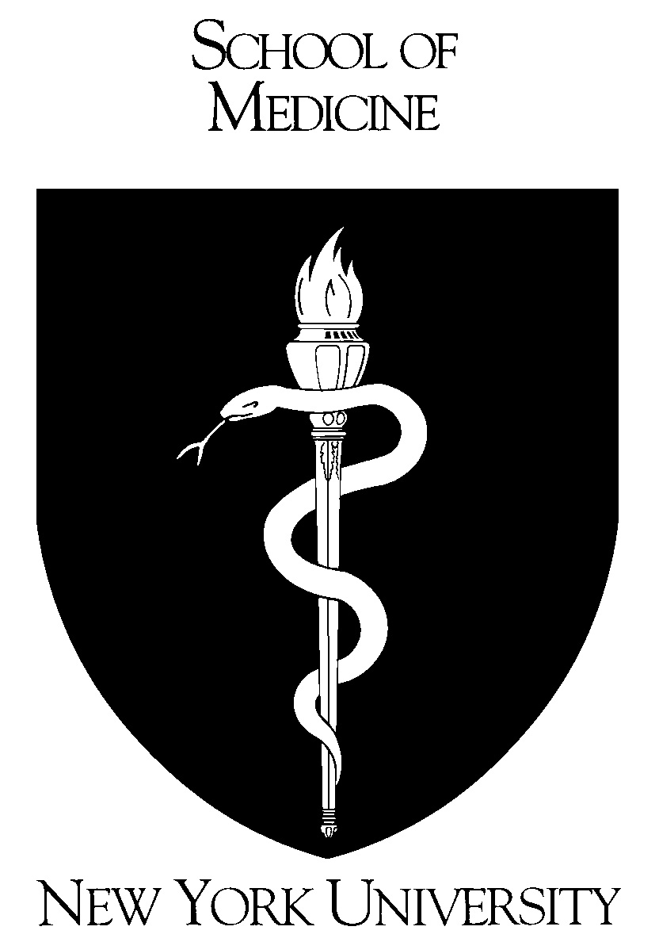
Sponsored by the
NYU Post-Graduate Medical School
Supported by educational grants from:
Amgen & Wyeth Pharmaceuticals; Bristol-Myers Squibb;
Centocor, Inc.; Genentech/Biogen IDEC;
Roche Laboratories

Target Audience
This program is intended for physicians and allied healthcare professionals in the fields of rheumatology, orthopedics and internal medicine.

Statement of Need
New therapies are available for rheumatoid arthritis (e.g., TNF blockers. Additional therapeutic strategies (e.g., new approaches to TNF blockade, IL-6-targeted therapy) appear poised to be introduced in the foreseeable future. There is a need for physicians to understand the proper use of the newer treatments, particularly when used in combination with existing disease modifying treatments. Fibromyalgia is a common and frequently debilitating disease. To date, therapy for fibromyalgia has been off-label and largely empirically-based. Recently the FDA approved the first drug for fibromyalgia. There is a need for physicians to understand the pathophysiology of fibromyalgia as well as the best practices for treating the condition, including the use of pregabalin vs older, off-label therapies. Osteoarthritis afflicts approximately 40 million Americans, but currently available therapies are analgesic and/or palliative. New insights into the pathophysiology of osteoarthritis raise the possibility of developing disease-modifying agents. Physicians treating OA patients need to know the best current practices for OA therapy, and recognize the implications of current research on future therapies. The pathophysiology and recommended treatments for childhood arthritides differ from those for adult patients, and new treatments for pediatric arthritides are available whose use may differ from their use in adult populations. Rheumatologists treating children with arthritis need to be knowledgeable about both well-established and newly-available therapies. Skin involvement in lupus presents with a wide range of potential findings, but since rheumatologists are not formally trained in dermatology, they may not always recognize the rashes of lupus or know the best treatments for these conditions. Giant cell arteritis is a form of vasculitis that carries a risk of disastrous outcomes including blindness. While steroids are effective in many patients, some patients respond poorly or fail to tolerate the treatment. For these patients, there is a strong need for better insights into, and approaches for, vasculitis management.

Educational Objectives
- recognize the new therapies available for the treatment of rheumatoid arthritis and develop individualized treatment plans to ameliorate symptoms, improve joint function and slow disease progression;
- distinguish between the currently available therapies for fibromyalgia, and based on best-practice data, develop decision making protocols for optimizing therapy for individual patients;
- apply knowledge of osteoarthritis pathophysiology and therapeutic best-practices to develop treatment plans that provide optimum benefit with minimal risk to specific patients;
- recognize the indications and contraindications for both established and newer therapies available for the treatment of pediatric arthritis, and develop a treatment plan for the safe, appropriate and effective treatment of pediatric arthritis patients;
- identify specific rash types on lupus patients, and treat and monitor appropriately with the most effective medications;
- identify patients who are failing or are likely to fail conventional therapy for giant cell arteritis, and institute appropriate alternative treatments.

Accreditation Statement
The NYU Post-Graduate Medical School is accredited by the Accreditation Council for Continuing Medical Education (ACCME) to provide continuing medical education for physicians.

Credit Designation Statement
The NYU Post-Graduate Medical School designates this educational activity for a maximum of 7 AMA PRA Category 1 CreditsTM. Physicians should only claim credits commensurate with the extent of their participation in the activity.

Method of Participation
To receive up to 7 CME credits, read this supplement, which should take 7 hours of your time, complete the post-test with a minimum passing grade of 70%, complete the evaluation, and submit to the NYU Post-Graduate Medical School (instructions enclosed).

This activity is valid for credit from October 15, 2008 through October 14, 2009.

Faculty Credentials

Steven B. Abramson, MD
Professor of Medicine and Pathology
NYU School of Medicine
New York, NY

Clifton Bingham, MD
Professor of Medicine
Johns Hopkins University
School of Medicine
Baltimore, MD
Lindsey Criswell, MD
Professor of Medicine
University of California San Francisco
San Francisco, CA

Gary Hoffman, MD
Professor of Medicine
Cleveland Clinic Foundation
Cleveland, OH

Stephen Honig, MD
Clinical Associate Professor of Medicine
NYU School of Medicine
New York, NY

David Hunter, MD
Professor of Medicine
Boston University School of Medicine
Boston, MA

Michael Lockshin, MD
Professor of Medicine
Weill Medical College of
Cornell University
New York, NY

Philip Mease, MD
Clinical Professor of Medicine
University of Washington
School of Medicine
Seattle, WA

Michael H. Pillinger, MD
Associate Professor of Medicine
and Pharmacology
NYU School of Medicine
New York, NY

Theodore Pincus, MD
Clinical Professor of Medicine
NYU School of Medicine
New York, NY

James Tumlin, MD
Associate Professor of Medicine
Emory University Medical School
Charlotte, NC

John Varga, MD
Professor of Medicine
Northwestern University
Feinberg School of Medicine
Chicago, IL

Joan von Feldt, MD

Associate Professor of Medicine
University of Pennsylvania
Philadelphia, PA

Yusuf Yazici, MD
Assistant Professor of Medicine
NYU School of Medicine
New York, NY

Disclosure Statement
The NYU Post-Graduate Medical School adheres to ACCME Essential Areas and policies, including the Standards for Commercial Support, regarding industry support of continuing medical education. In order to resolve any identified conflicts of interest, disclosure information is provided during the planning process to ensure resolution of any identified conflicts. Disclosure of faculty and commercial relationships as well as the discussion of unlabeled or unapproved use of any drug, device or procedure by the faculty is listed below.

Steven B. Abramson, MD serves as a consultant to Novartis Pharmaceuticals Corp., Merck & Co., Inc., Pfizer, Inc., Schering-Plough, CombinatoRx and Amgen.

Clifton O. Bingham, III, MD serves as a consultant to Abbott Laboratories, Amgen, Novartis Pharmaceuticals Corp., Merck & Co., Genentech, Targeted Genetics and NiCox. He is the recipient of research funding from Genentech and Wyeth Pharmaceuticals. He is also the recipient of educational grant support from Abbott Laboratories, Amgen, Bristol-Myers Squibb, Genentech and Centocor, Inc.

Lindsey Criswell, MD, MPH has no financial relationships to disclose.

Gary S. Hoffman, MD has no financial relationships to disclose.

Stephen Honig, MD serves on the speakers’ bureau of Novartis Pharmaceuticals Corp.

David Hunter, MBBS, MSc, PhD is the recipient of research funding from DonJoy, Inc., Pfizer, Inc., Merck & Co., Inc., AstraZeneca Pharmaceuticals LP and Wyeth Pharmaceuticals.

Michael Lockshin, MD has no financial relationships to disclose. Dr. Lockshin’s presentation will include discussion of the unlabeled or unapproved use of a drug, device or procedure; i.e., rituximab, heparin.

Philip Mease, MD serves as a consultant to Amgen, Abbott Laboratories, Biogen IDEC, Centocor, Genentech, Roche Laboratories, Wyeth Pharmaceuticals and UCB, Inc. He also serves on the speakers’ bureau of Amgen, Abbott Laboratories, Biogen IDEC, Centocor, Genentech and Wyeth Pharmaceuticals. In addition, Dr. Mease is the recipient of research funding from Amgen, Abbott Laboratories, Biogen IDEC, Centocor, Genentech, Roche Laboratories and Wyeth Pharmaceuticals.

Michael Pillinger, MD has no financial relationships to disclose.

Theodore Pincus, MD serves as a consultant to UCB, Inc., Bristol-Myers Squibb and Abbott Laboratories. He is the recipient of research funding from Bristol-Myers Squibb and Amgen.

James A. Tumlin, MD serves as a consultant to FlowMedica Corp., GE Healthcare, Genentech, Ineos Corporation. He is the recipient of research funding from FlowMedica Corp., GE Healthcare, Genentech, Abbott Pharmaceuticals and Ineos Corporation.

John Varga, MD is the recipient of research funding from Novartis Pharmaceuticals Corp. Dr. Varga’s presentation will include discussion of the unlabeled or unapproved use of a product; i.e, imatinib mesylate.

Joan Von Feldt, MD serves as a consultant to Genentech/Biogen IDEC and Amgen. Dr. Von Feldt’s presentation will include discussion of the unlabeled or unapproved use of a drug, device or procedure; i.e., hydroxychloroquine and rituximab.
Yusuf Yazici, MD serves as a consultant to Roche Laboratories, Celgene, Bristol-Myers Squibb Co. and Centocor, and serves on the speakers’ bureau of Pfizer, Inc. and Bristol-Myers Squibb Co.

The independent reviewer of this activity has no financial relationships to disclose.

Copyright © 2008, the NYU Post-Graduate Medical School. All rights reserved.

